**AWS(Amazon Web Services)**

In 2006, **Amazon Web Services (AWS)** started to offer IT services to the market in the form of web services, which is nowadays known as **cloud computing**. With this cloud, we need not plan for servers and other IT infrastructure which takes up much of time in advance. Instead, these services can instantly spin up hundreds or thousands of servers in minutes and deliver results faster. We pay only for what we use with no up-front expenses and no long-term commitments, which makes AWS cost efficient.

Today, AWS provides a highly reliable, scalable, low-cost infrastructure platform in the cloud that powers multitude of businesses in 190 countries around the world.

**AWS ─ Basic Architecture**

This is the basic structure of **AWS EC2,** where **EC2** stands for Elastic Compute Cloud. EC2 allow users to use virtual machines of different configurations as per their requirement. It allows various configuration options, mapping of individual server, various pricing options, etc. We will discuss these in detail in AWS Products section. Following is the diagrammatic representation of the architecture.

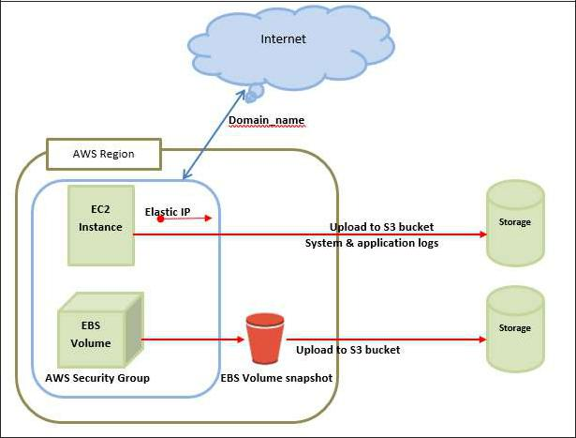

**Note:** In the above diagram **S3** stands for Simple Storage Service. It allows the users tostore and retrieve various types of data using API calls. It doesn’t contain any computing element. We will discuss this topic in detail in AWS products section.

**Load Balancing**

**Load balancing** simply means to hardware or software load over web servers, thatimprovers the efficiency of the server as well as the application. Following is the diagrammatic representation of AWS architecture with load balancing.

Hardware load balancer is a very common network appliance used in traditional web application architectures.

WS provides the Elastic Load Balancing service, it distributes the traffic to EC2 instances across multiple available sources, and dynamic addition and removal of Amazon EC2 hosts from the load-balancing rotation.

**Elastic Load Balancing** can dynamically grow and shrink the load-balancing capacity toadjust to traffic demands and also support sticky sessions to address more advanced routing needs.

**Amazon Cloud-front**

It is responsible for content delivery, i.e. used to deliver website. It may contain dynamic, static, and streaming content using a global network of edge locations. Requests for content at the users’ end are automatically routed to the nearest edge location, which improves the performance.

Amazon Cloud-front is optimized to work with other Amazon Web Services, like Amazon S3 and Amazon EC2. It also works fine with any non-AWS origin server and stores the original files in a similar manner.

In Amazon Web Services, there are no contracts or monthly commitments. We pay only for as much or as little content as we deliver through the service.

**Elastic Load Balancer**

It is used to spread the traffic to web servers, which improves performance. AWS provides the Elastic Load Balancing service, in which traffic is distributed to EC2 instances over multiple available zones, and dynamic addition and removal of Amazon EC2 hosts from the load-balancing rotation.

Elastic Load Balancing can dynamically grow and shrink the load-balancing capacity as per the traffic conditions.

**Security Management**

Amazon’s Elastic Compute Cloud (EC2) provides a feature called security groups, which is similar to an inbound network firewall, in which we have to specify the protocols, ports, and source IP ranges that are allowed to reach your EC2 instances.

Each EC2 instance can be assigned one or more security groups, each of which routes the appropriate traffic to each instance. Security groups can be configured using specific subnets or IP addresses which limits access to EC2 instances.

**Elastic Caches**

Amazon Elastic Cache is a web service that manages the memory cache in the cloud. In memory management, cache has a very important role and helps to reduce the load on the services, improves the performance and scalability on the database tier by caching frequently used information.

**Amazon RDS**

Amazon RDS (Relational Database Service) provides a similar access as that of MySQL, Oracle, or Microsoft SQL Server database engine. The same queries, applications, and tools can be used with Amazon RDS.

It automatically patches the database software and manages backups as per the user’s instruction. It also supports point-in-time recovery. There are no up-front investments required, and we pay only for the resources we use.

**Hosting RDMS on EC2 Instances**

Amazon RDS allows users to install RDBMS (Relational Database Management System) of your choice like MySQL, Oracle, SQL Server, DB2, etc. on an EC2 instance and can manage as required.

Amazon EC2 uses Amazon EBS (Elastic Block Storage) similar to network-attached storage. All data and logs running on EC2 instances should be placed on Amazon EBS volumes, which will be available even if the database host fails.

Amazon EBS volumes automatically provide redundancy within the availability zone, which increases the availability of simple disks. Further if the volume is not sufficient for our databases needs, volume can be added to increase the performance for our database.

Using Amazon RDS, the service provider manages the storage and we only focus on managing the data.

**Storage & Backups**

AWS cloud provides various options for storing, accessing, and backing up web application data and assets. The Amazon S3 (Simple Storage Service) provides a simple web-services interface that can be used to store and retrieve any amount of data, at any time, from anywhere on the web.

Amazon S3 stores data as objects within resources called **buckets**. The user can store as many objects as per requirement within the bucket, and can read, write and delete objects from the bucket.

Amazon EBS is effective for data that needs to be accessed as block storage and requires persistence beyond the life of the running instance, such as database partitions and application logs.

Amazon EBS volumes can be maximized up to 1 TB, and these volumes can be striped for larger volumes and increased performance. Provisioned IOPS volumes are designed to meet the needs of database workloads that are sensitive to storage performance and consistency.

Amazon EBS currently supports up to 1,000 IOPS per volume. We can stripe multiple volumes together to deliver thousands of IOPS per instance to an application.

**Auto Scaling**

The difference between AWS cloud architecture and the traditional hosting model is that AWS can dynamically scale the web application fleet on demand to handle changes in traffic.

In the traditional hosting model, traffic forecasting models are generally used to provision hosts ahead of projected traffic. In AWS, instances can be provisioned on the fly according to a set of triggers for scaling the fleet out and back in. Amazon Auto Scaling can create capacity groups of servers that can grow or shrink on demand.

**Key Considerations for Web Hosting in AWS**



Following are some of the key considerations for web hosting:

**No physical network devices needed**

In AWS, network devices like firewalls, routers, and load-balancers for AWS applications no longer reside on physical devices and are replaced with software solutions.

Multiple options are available to ensure quality software solutions. For load balancing choose Zeus, HAProxy, Nginx, Pound, etc. For establishing a VPN connection choose OpenVPN, OpenSwan, Vyatta, etc.

**No security concerns**

AWS provides a more secured model, in which every host is locked down. In Amazon EC2, security groups are designed for each type of host in the architecture, and a large variety of simple and tiered security models can be created to enable minimum access among hosts within your architecture as per requirement.

**Availability of data centers**

EC2 instances are easily available at most of the availability zones in AWS region and provides model for deploying your application across data centers for both high availability and reliability.

## How do you sign up on AWS?

Step 1: Go to aws.amazon.com and click on Create an AWS Account.

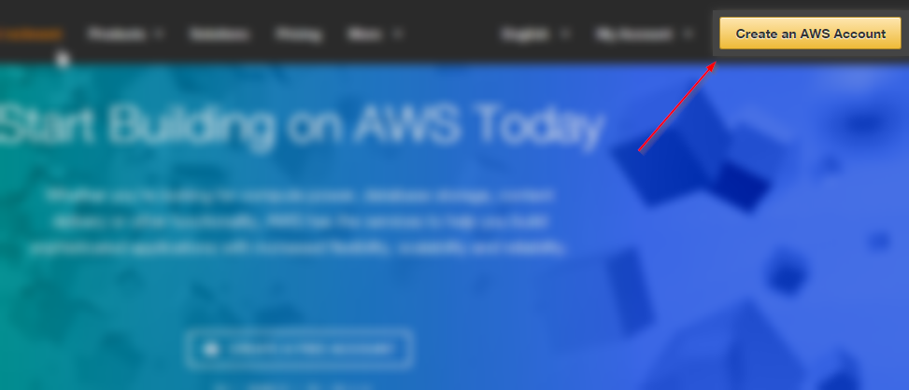

Step 2:Click on I am a new customer’ option, enter your email address and at last click on Sign In.

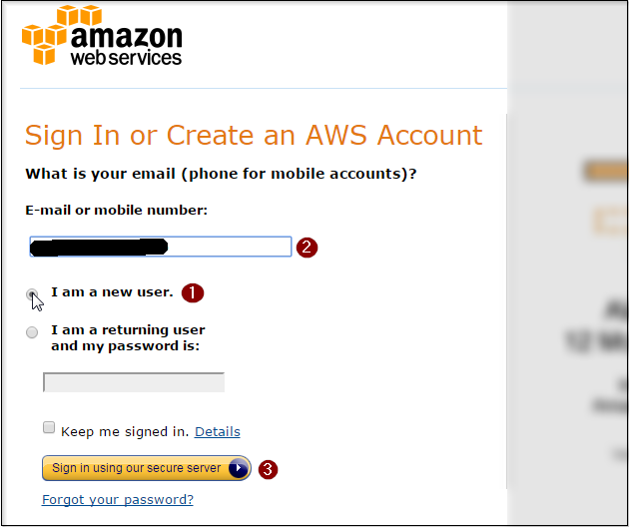

Step3:On the next page,fill-in all the relevant information and click on Create Account.

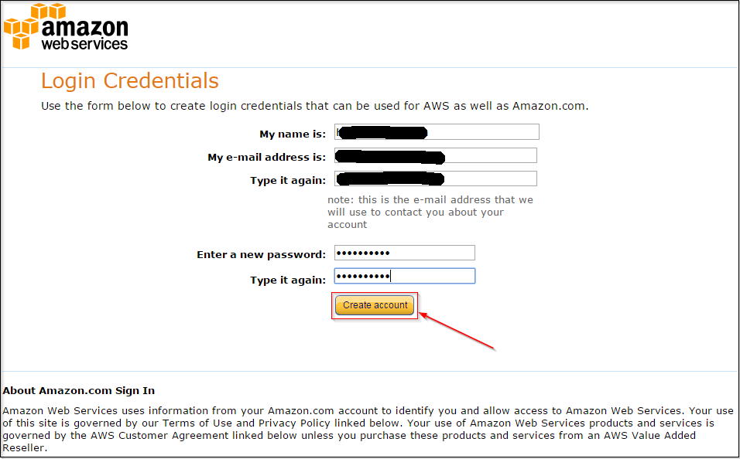

Step 4: On the next page, fill in your personal details and click on Create Account.

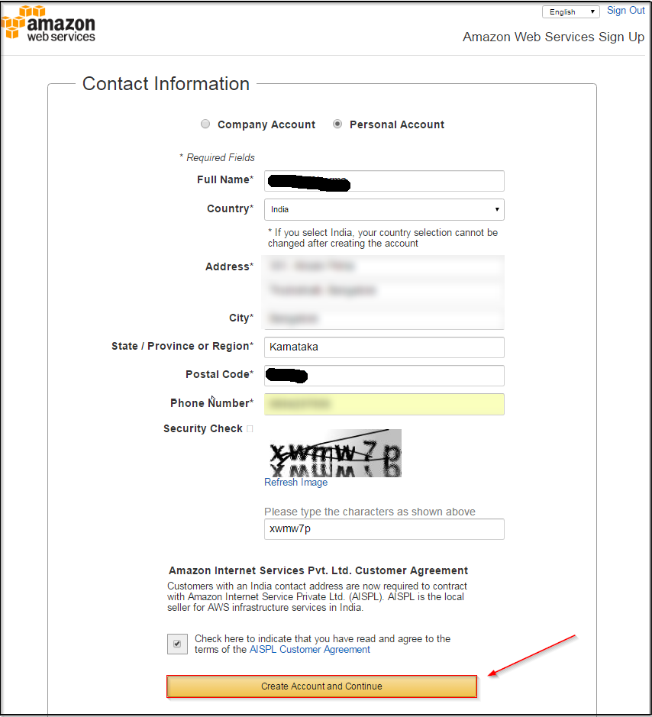

Step 5: You would be asked to enter your credit or debit card details on this page, once you do that, proceed by clicking on continue.

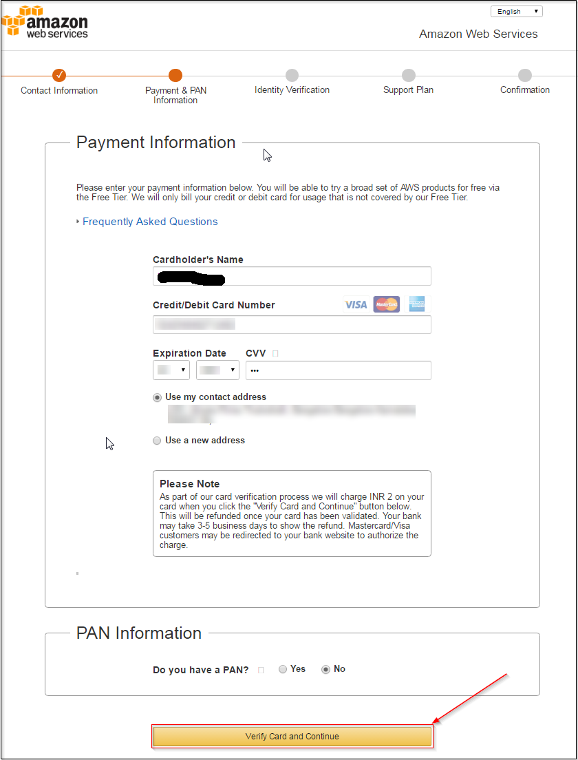

Step 6:Next Step would be to verify your phone number, enter the details and click on Call me Now.

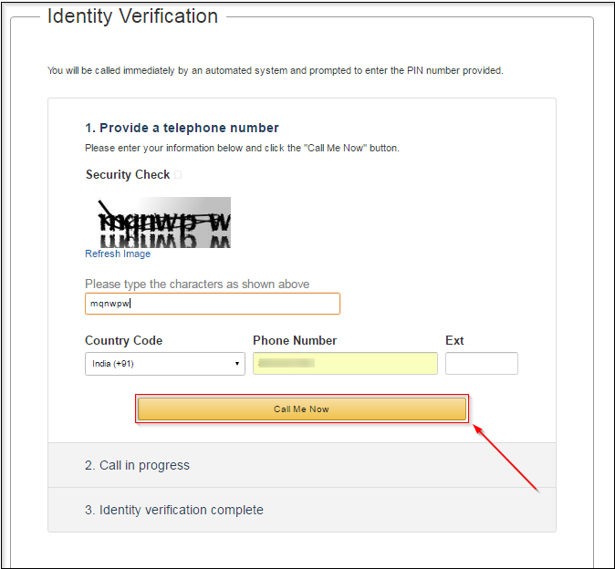

Step 7: You will get a call from AWS and will be asked to enter a pin, next up you will be selecting your plan for AWS, but before that click on Next.

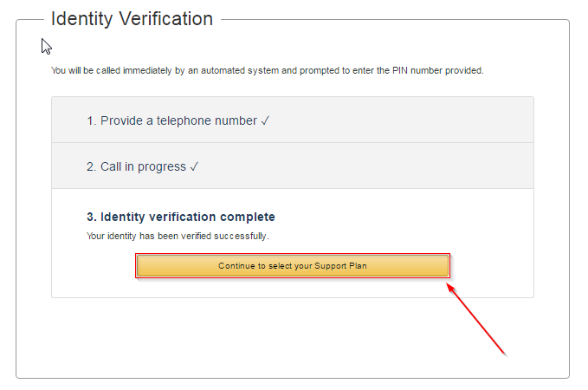

Step 8: You shall select a plan, which suits you, I will be going with a basic plan since this account would be for personal use.

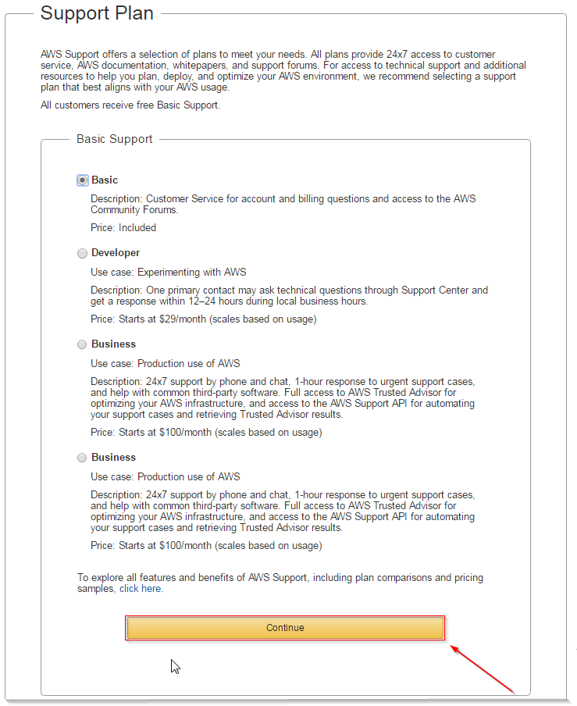

Step 9: Congrats! Your AWS Account is ready to be used! Go sign in and play!

**What is the AWS Free Usage Tier ?**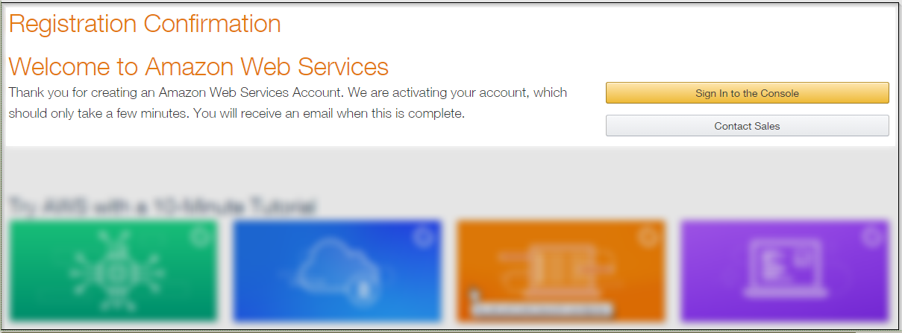

AWS is offering a free usage tier for new AWS customers. Per month, the AWS free usage tier covers:

750 hours of Amazon EC2 Linux or RHEL or SLES t2.micro instance usage (1 GiB of memory and 32-bit and 64-bit platform support) – enough hours to run continuously each month*

750 hours of Amazon EC2 Microsoft Windows Server† t2.micro instance usage (1 GiB of memory and 32-bit and 64-bit platform support) – enough hours to run continuously each month*

750 hours of an Elastic Load Balancer plus 15 GB data processing*

750 hours of Amazon RDS Single-AZ Micro DB Instances, running MySQL, MariaDB, PostgreSQL, Oracle BYOL or SQL Server Express Edition – enough hours to run a DB Instance continuously each month. You also get 20 GB of database storage and 20 GB of backup storage.*

750 hours of Amazon ElastiCache Micro Cache Node usage – enough hours to run continuously each month. *

30 GB of Amazon Elastic Block Storage in any combination of General Purpose (SSD) or Magnetic, plus 2 million I/Os (with EBS Magnetic) and 1 GB of snapshot storage***

5 GB of Amazon S3 standard storage, 20,000 Get Requests, and 2,000 Put Requests*

25 GB of Storage, 25 Units of Read Capacity and 25 Units of Write Capacity, enough to handle up to 200M requests per month with Amazon DynamoDB.**

25 Amazon SimpleDB Machine Hours and 1 GB of Storage**

1,000 Amazon SWF workflow executions can be initiated for free. A total of 10,000 activity tasks, signals, timers and markers, and 30,000 workflow-days can also be used for free**

100,000 Requests of Amazon Simple Queue Service**

100,000 Requests, 100,000 HTTP notifications and 1,000 email notifications for Amazon Simple Notification Service**

10 Amazon Cloudwatch metrics, 10 alarms, and 1,000,000 API requests**

50 GB Data Transfer Out, 2,000,000 HTTP and HTTPS Requests for Amazon CloudFront*

15 GB of bandwidth out aggregated across all AWS services*

* These free tiers are only available to existing AWS customers who have signed-up for Free Tier after October 20, 2010 and new AWS customers, and are available for 12 months following your AWS sign-up date. When your free usage expires or if your application use exceeds the free usage tiers, you simply pay standard, pay-as-you-go service rates (see each service page for full pricing details). Restrictions apply; see offer terms for more details.

For EC2 and RDS Free Tier, t1.micro may be substituted for t2.micro.

The S3 Free Tier will only apply to storage in the Standard Storage class.

**These free tiers are available to both existing and new AWS customers indefinitely. For EC2 and RDS Free Tier, t1.micro may be substituted for t2.micro.

***If the combined usage is still under 30GB, both will be free. If the combined usage is over 30GB, the more expensive storage will count against the free tier first.

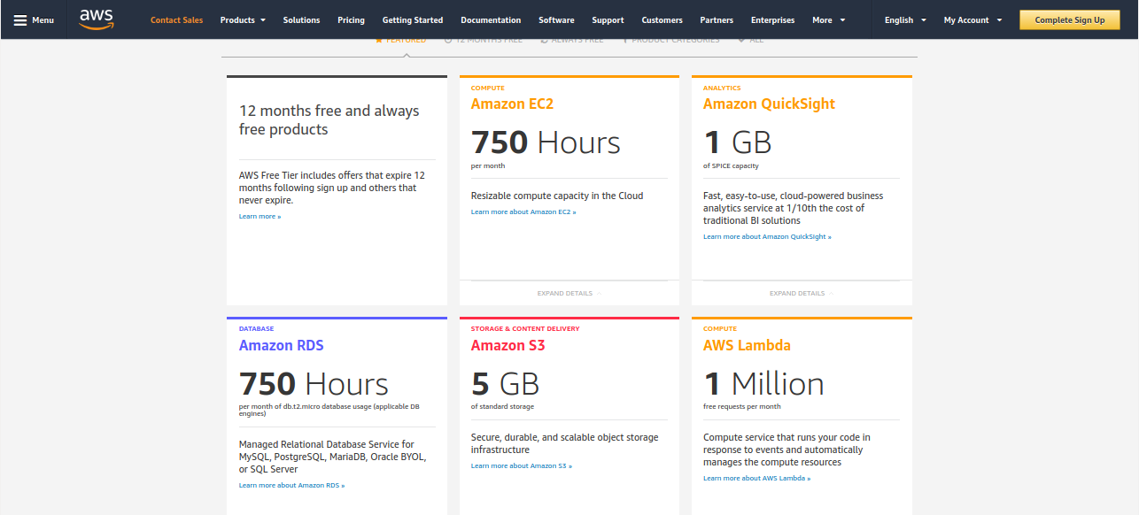

# **Working with the AWS Management Console**

Welcome to the AWS Management Console. This guide provides a short introduction to working with the console. To learn how to work with individual services in the console.

Topics

* What Is the AWS Management Console?
* Getting Started with a Service
* Adding and Removing Shortcuts
* Selecting a Region
* Changing Your Password
* Getting Billing Information
* Using the Device of Your Choice
* Troubleshooting

## **What Is the AWS Management Console?**

The AWS Management Console is a web application that comprises and refers to a broad collection of service consoles for managing Amazon Web Services. When you first sign in, you see the console home page.

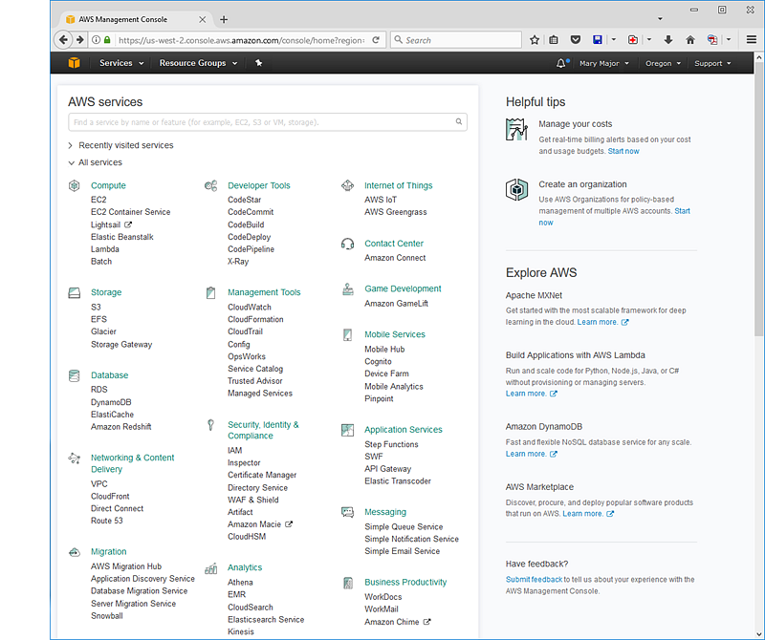

The home page provides access to each service console as well as an intuitive user interface for exploring AWS and getting helpful tips. Among other things, the individual service consoles offer tools for working with Amazon S3buckets, launching and connecting to Amazon EC2 instances, setting Amazon CloudWatch alarms, and getting information about your account and about billing.

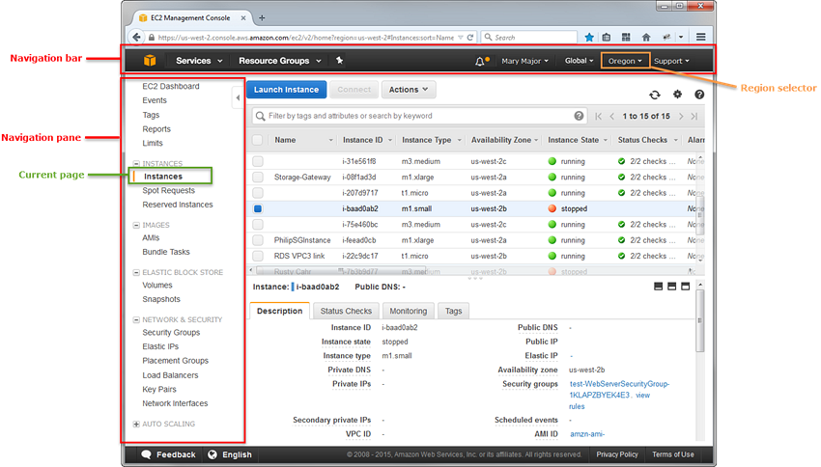

## **Getting Started with a Service**

The AWS Management Console provides multiple ways for navigating to individual service consoles.

**To open a console for a service**

Do one of the following:

* Type the name of the service in the search box. Then choose the service that you want from the list of search results.

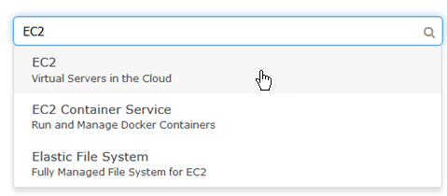

* Choose one of your recently visited services under the search box.
* Choose **Services** to open a full list of services. On the upper right of the page, choose **Group** to see the services listed by category or choose **A–Z** to see an alphabetical listing. Then choose the service that you want.

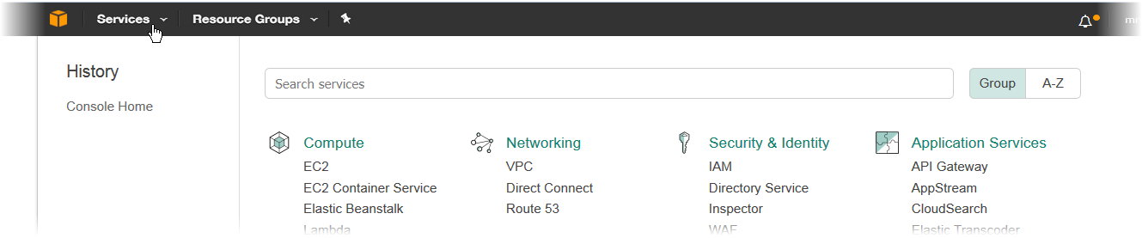

## **Adding and Removing Shortcuts**

You can add shortcuts for the consoles that you use most.

**To add a shortcut**

1. On the navigation bar, choose the pushpin icon.

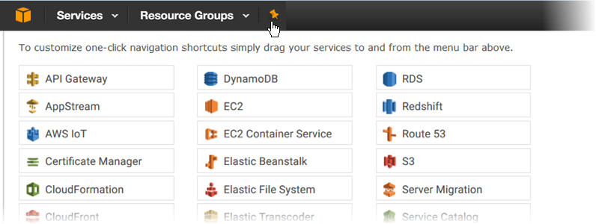

1. Drag a service from the menu to the navigation bar.

You can add more shortcuts and drop them onto the navigation bar in any order that you want.



**To remove a shortcut**

1. On the navigation bar, choose the pushpin icon.
2. Drag the shortcut off the navigation bar.

## **Selecting a Region**

For many services, you can select a region that specifies where your resources are managed. You do not select a region for the AWS Management Console or for some services, such as IAM.

**To select a region**

1. In the AWS Management Console, choose a service to go to that service's console.
2. In the navigation bar, choose the name of the currently selected region.

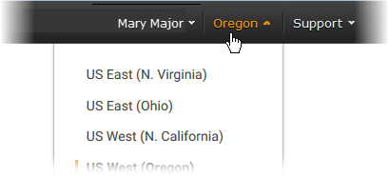

When you select a region, that region becomes the default in the console.

**Note**

If you have created AWS resources, but you don’t see those resources in the console, the console might be displaying resources from a different region. Some resources (such as EC2 instances) are created in a specific region. To see them, use the region selector to choose the region in which the resources were created.

## **Changing Your Password**

If you are an account owner, you can change your AWS account password from the AWS Management Console.

**To change your password**

1. In the navigation bar, choose your account name.



1. Choose **Security Credentials**.
2. The page you see varies with the type of account that you used to sign in. Follow the console instructions to get to the page for changing your password.
3. Type your current password once and your new password twice.

The new password must be at least eight characters long and must include a symbol, a number, an uppercase letter, and a lowercase letter.

1. When you've completed the password form, choose **Change Password** or **Save changes**.

## **Getting Billing Information**

If you have the necessary permissions, you can get information about your AWS charges from the console.

**To get your billing information**

1. In the navigation bar, choose your account name.
2. Choose **My Billing Dashboard**.
3. Use the AWS Billing and Cost Management dashboard to find a summary and a breakdown of your monthly spending. To learn more, see the AWS Billing and Cost Management User Guide.

## **Using the Device of Your Choice**

The AWS Management Console has been designed to work on tablets as well as other kinds of devices:

* Horizontal and vertical space is maximized to show more on your screen.
* Buttons and selectors are larger for a better touch experience.

The AWS Management Console is also available as an app for Android and iOS. This app provides mobile-relevant tasks that are a good companion to the full web experience. For example, you can easily view and manage your existing Amazon EC2 instances and Amazon CloudWatch alarms from your phone.

Here's what the Android app looks like running on a Kindle Fire HDX 7":

